RETREAT - CHAPTER 2019
Our 36th year
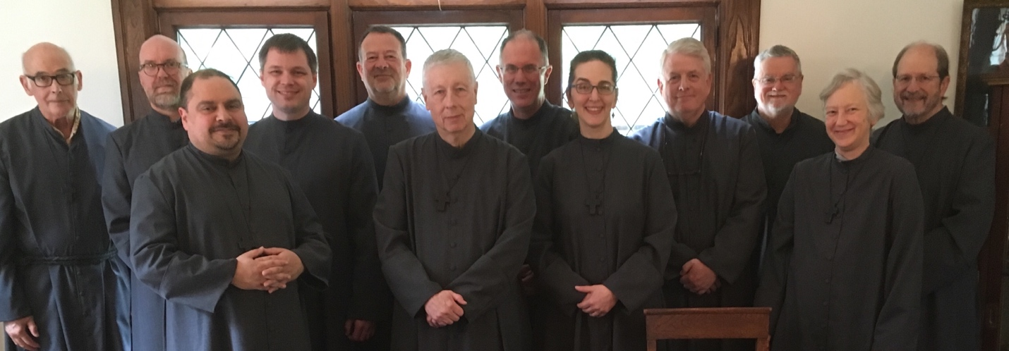

Retreat - Chapter unfolded this way -
The sisters and brothers came from Florida and Georgia, Seattle and New York, Kentucky and Delaware. We met at the convent of the Community of Saint John Baptist.
We gathered Monday evening for dinner and a go around the circle sharing of some significant thing in each member's life. That closed with Compline and a social time.
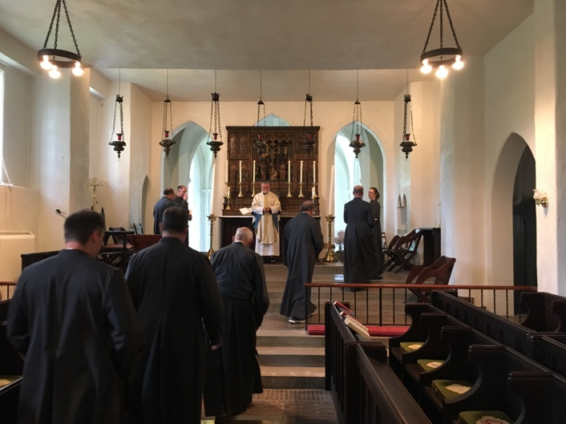Worship was in the threefold rule of prayer pattern -- Eucharist, Daily Office and Personal Devotions. We ended up using the larger sister's chapel this year. During the Eucharist we all faced east together. It had been some years for most of us. The sense of transcendence and equality in worship was emphasized by the shift. The space did allow us to gather around the altar with the presider and the communicate one another.
The Divine Office was said in choir. Lauds was with the sisters in the Saint Michael Chapel. The Eucharist, Evening Prayer and Compline was in the larger chapel on our own.
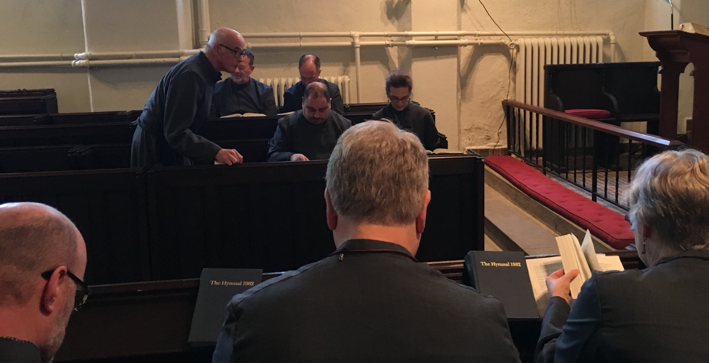Personal devotions had its own time both in the afternoon periods of silence, Centering Prayer prior to Mass, and according to individual needs and gifts throughout the day.
Mutual Spiritual Guidance was in the morning on three days. This year we engaged exercises around life lines as related to being part of OA and friendship. We grounded the discussion in a quote from John Paul II on formation in apostolic communities. The quote.
We also reflected on friendship in the Order. Quotes on friendship in the Rule, and the sermon of Fr. Emmett Jarrett, were used.
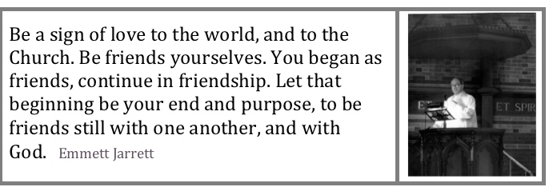
Chapter took place toward the beginning of retreat and on Thursday evening and Friday morning. Our reflection and decisions included issues such as: Invitation 2019: Adoration, Awe, Service: thoughts on the burials of Professed Members; reprinting Fill All Things and more use of ebooks; increasing the visits of our Episcopal Companion; and a number of administrative items.
Social time was at most meals, in the evening and on Wednesday when we have dinner out.
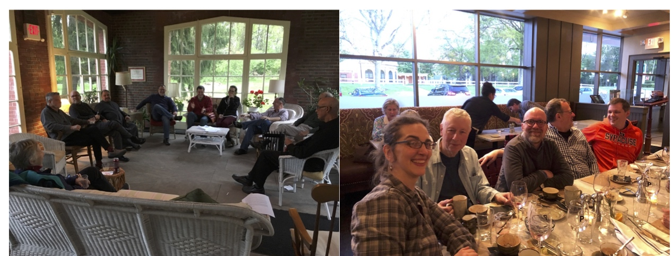

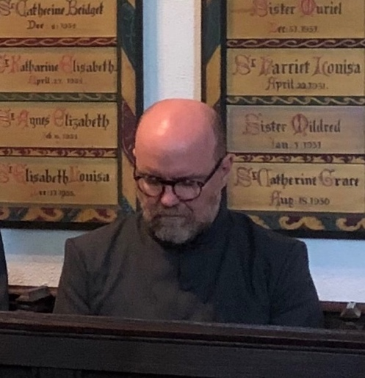First Promise & Clothing - Fr. Richard Proctor, OA
Father Richard, OA took the Promise for the first time and was clothed. Here's the rite that was used after the homily during the Tuesday mass. Richard was presented and clothed by Fr. Lowell, OA and Bishop Scott, OA. The Promise was recieved by Sister Michelle, OA on behalf of the community.
Our schedule for the week

Our retreat at CSJB in 1989

